**BACKGROUND**

**body {**

**background-color**: #CEE; }

// image

**background-attachment**: fixed; // set image to keep even when you scroll

**background-image:** url(me.png); // set which image

**background-repeat:** no-repeat; // image will appear only 1 time

**background-position**: 0px 104px; // x-y from corner-left = top-left;

}

**html {**

**margin-top :** -21px; // para quitarle una parte superior a la imagen, solo si inicia en top

**background-image:** url(REPEATpng); // set which image, a background image color with shadow

**background-repeat:** repeat-x; // image will appear along x axis only

**background-position**: top left; // this is the default, top;

}

Color Mozilla de firefox

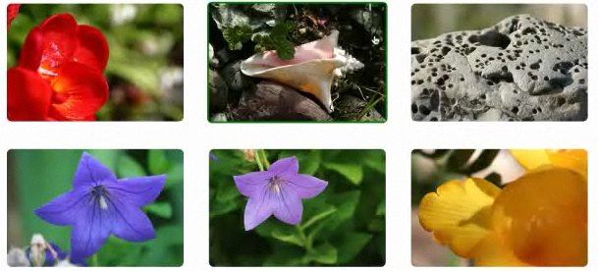

Images gallery, round corner, margin, and when hover show green border, second one has a green border

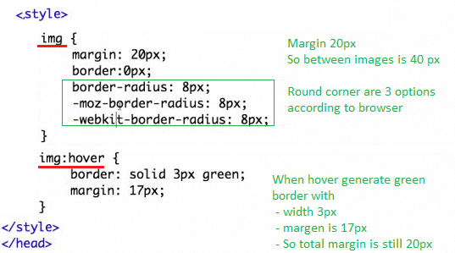

When clicking an image it goes to another page and shows only that image



**BACKGROUND IMAGE**

At the top is the word “Images” but we would like to include a background image and repeat the image in the top first line, and start in left position 20px

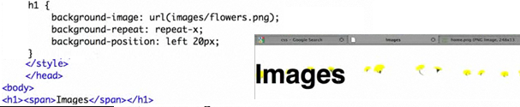

**IMAGE IN DIV**

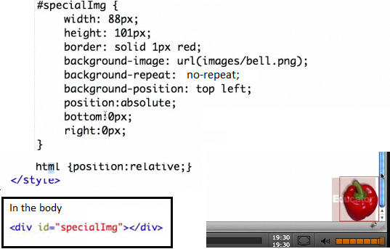

**ENHANCE HEADING BY REPLACING TEXT WITH AN IMAGE**

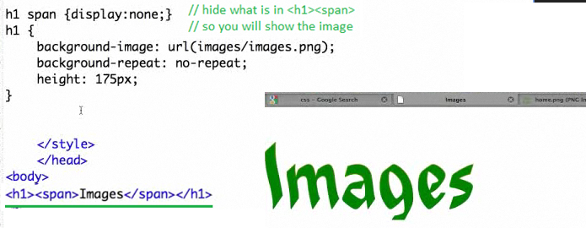

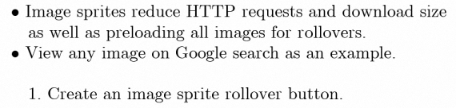

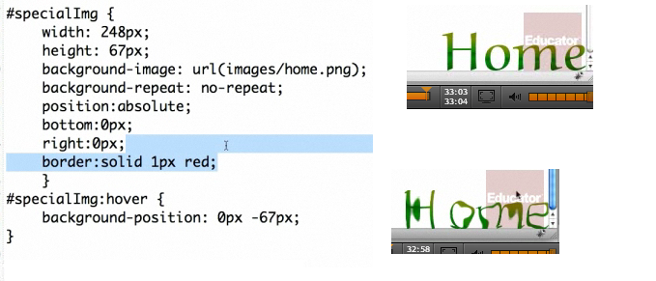

Right-click an image

Select View Image

